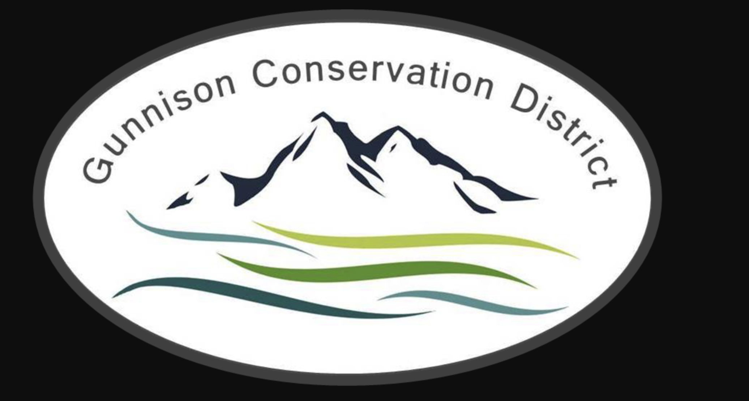
Gunnison Conservation District
216 N Colorado St
Gunnison, CO 81230
970–707-3047

AGENDA – Regular Meeting

MAY 16, 2023 6:00 PM
Meeting held at CPW Office, 300 W. New York Ave Gunnison CO 81230

Call to Order Bill Ketterhagen 6:00 PM

Partner Updates

N.R.C.S Dan Olson/Jamison Jeweks
Colorado State Forest Service Dylan Eimer
CSU Extension Hannah Kersting
Bird Conservancy of the Rockies Marcella Tarantino
U.G.R.W.C.D Beverly Richards
Trout Unlimited Jesse Krupthaut

Approval of Minutes Board

Treasurer’s Report Rufus Wilderson/Caroline Czenkusch
Financial Statements

Old Business
Fencing update Aleshia Rummel
Website live Caroline Czenkusch
By laws review Board

New Business
Turf replacement program Aleshia Rummel
Elections-Oath of Office Caroline Czenkusch
Upcoming Workshops Aleshia Rummel
Request Executive Session Non Board Members/staff excused

Next Meeting
GCD Board Meeting June 20, 2023
GCD Board Meeting July 18, 2023

Adjourn Bill Ketterhagen

